Doubly Linked List

**You do not need to write the DoublyNode class, createList()/printList()/count()/nodeAt() etc. functions unless specified in the problem.**

**Just design the function specified in the problem.**

**No need to write driver code.**

**This document is a compilation of previous semester’s exam (midterm/final) problems and lab quiz problems. Try to practice relevant problems from online judges as well.**

1.
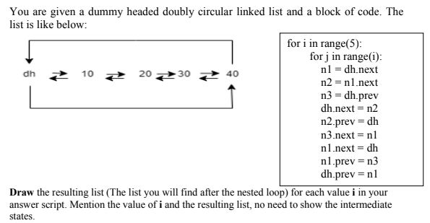
2.
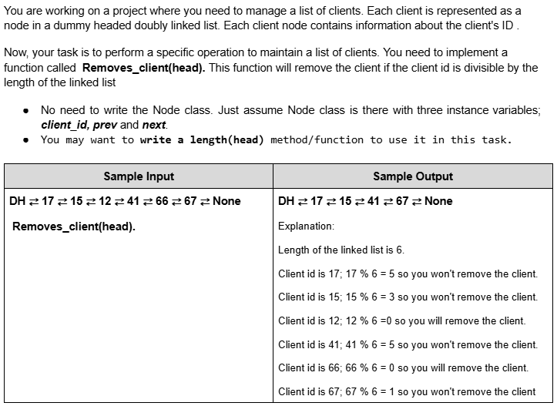
3.
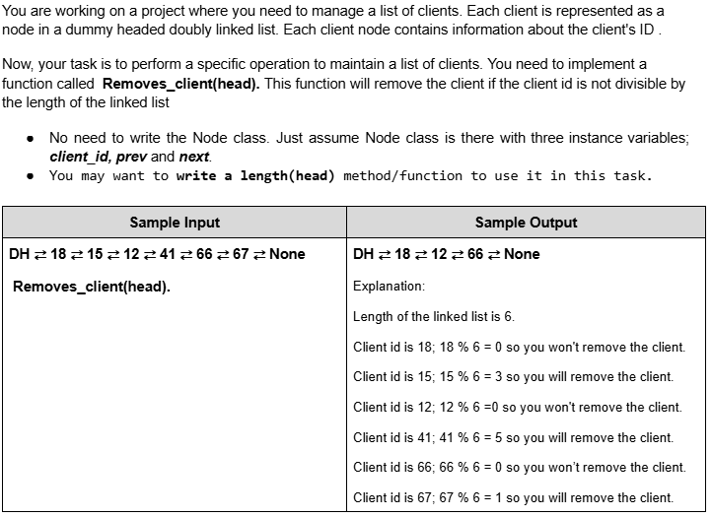
4.
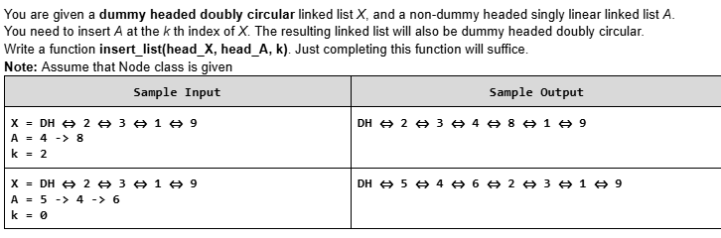

5.
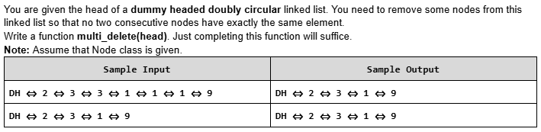
6.
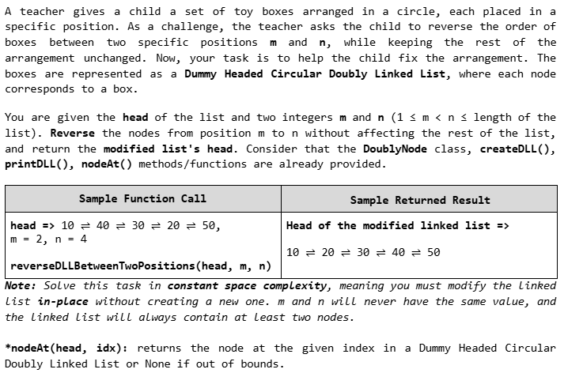

7.
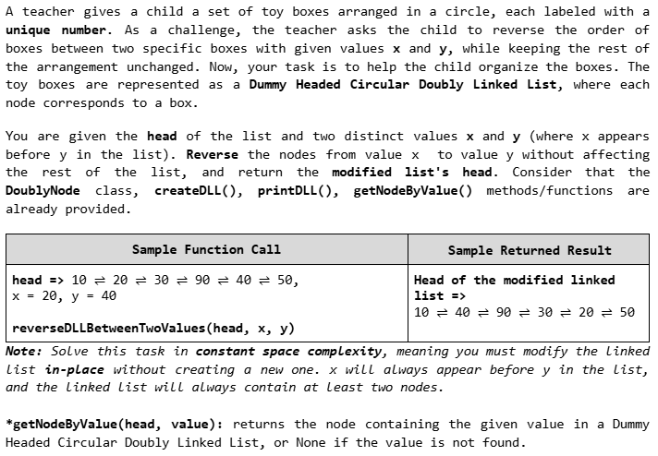
8.
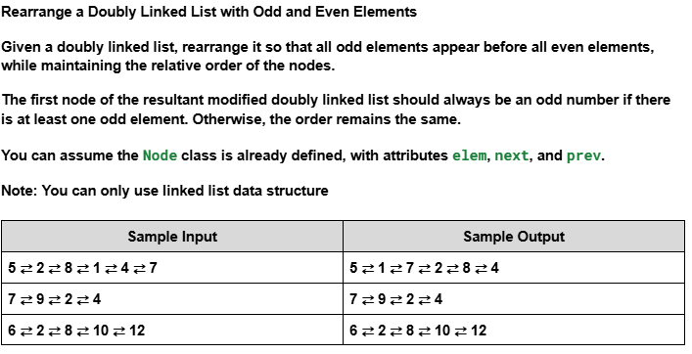

9.
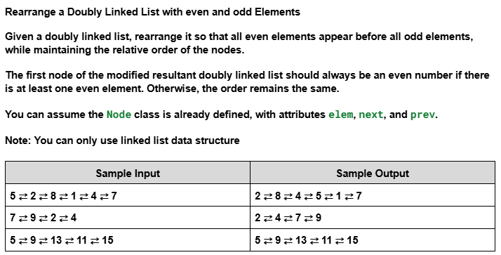
10.
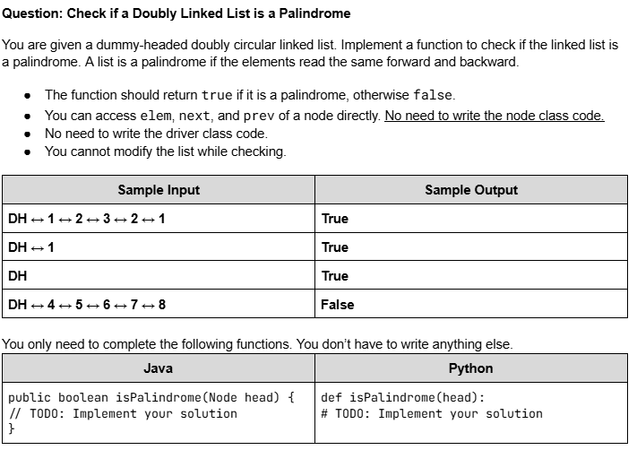

11.
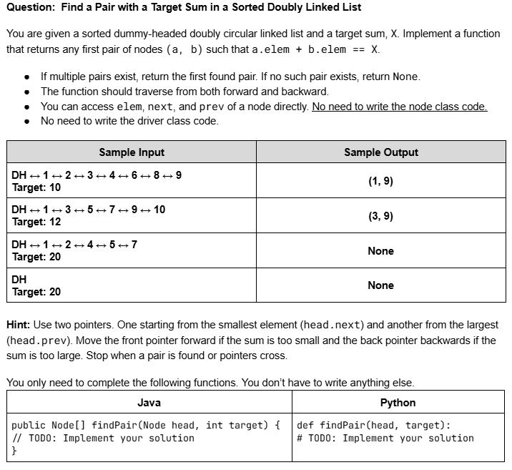
12.
Tasks from Book - Practice Sheet 4 - Doubly Linked List.pdf

13.
Tasks from Lab 2 - Lab 2 - Singly & Doubly LinkedList.docx

14.
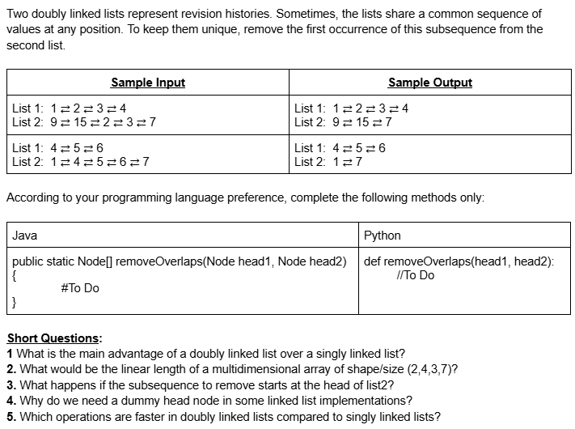
15.
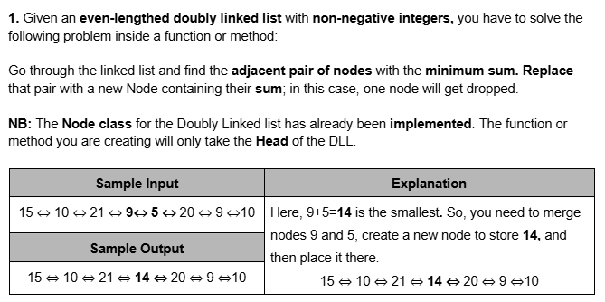
16.
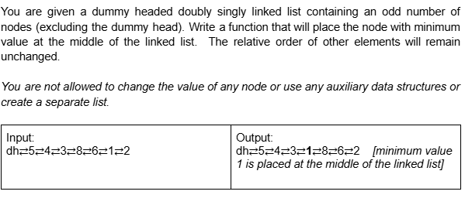
17.
